**Project 1 Documentation**

# Overview

The purpose of the test is to demonstrate good architectural design. The main 2 aspects of such design will be:

* Modularisation: Ability to reuse the module(s).
* Scalability: extend the functionality of the module(s).

# Constraints

* Browser support is latest Chrome, Firefox, Microsoft Edge.

# Background

I have an educational background in MIS but no job-related experience. I have dealt with multiple programming languages during my 4 year term at the University of Mississippi (i.e. java, css, html). I had no experience coding in Javascript before attempting this challenge.

As such, I used an MVC like approach in the design and development of this project.

I tackled the project as follows:

1. app.js (throughout the development of the app, using it to quickly test in-browser)
2. model.js (10 minutes)
3. view.js (30 minutes)
4. controller.js (30 minutes)
5. index.html

# Diagram

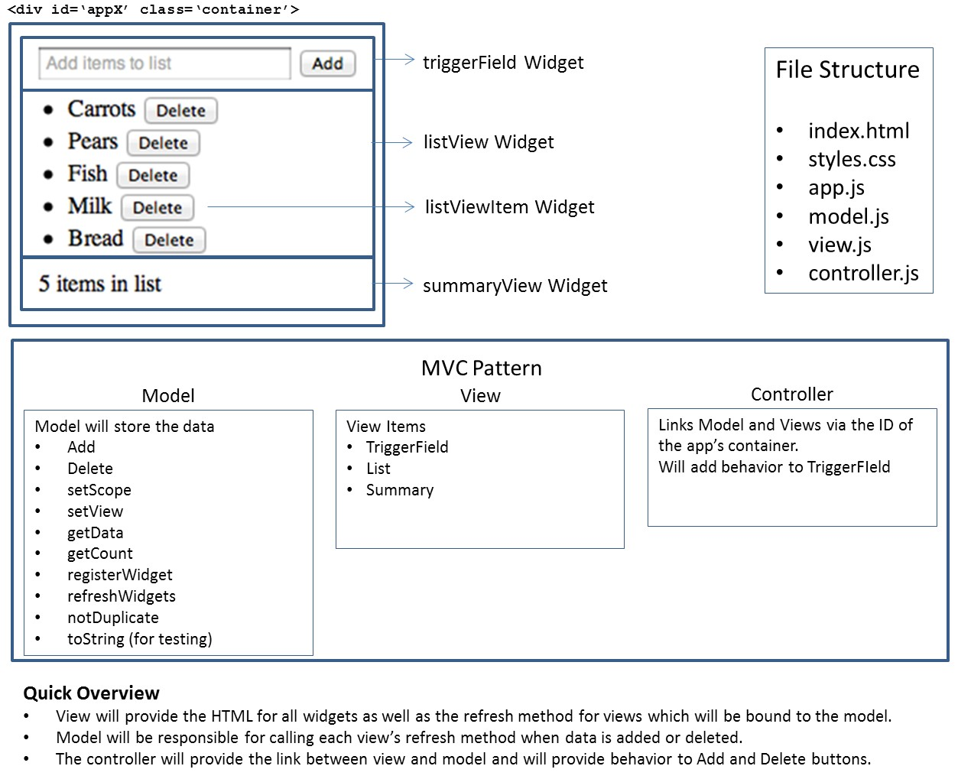

# Conclusion

So, this exercise, did not take as long as the following project. It is a simple add and delete functionality program that process the data once the enter key or button is pressed after inserting the text or “data” in the text box. Once processed, the data is stored in the model list box.

Desmond Yates